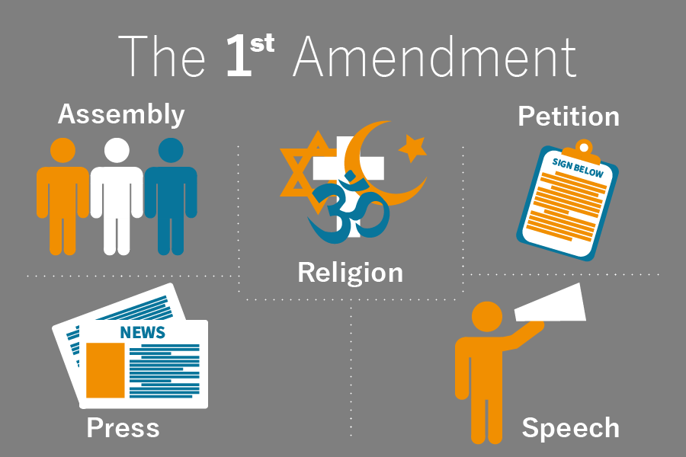

The 1st Amendment protects our:

* Freedom of Speech – to speak your mind (as long as it does not threaten others)
* Freedom of Religion – to practice whatever form of worship you choose
* Freedom of the Press – to print and publish books, newspapers, videos, etc
* Freedom of Assembly – to gather together
* Freedom to Petition – to ask our government officials to do something

***Together, this protects our freedom of expression!***

***TINKER V. DES MOINES* (1969): A BACKGROUND**

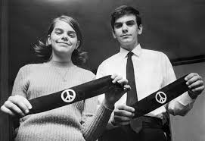

John and Mary Beth Tinker were public school students in Des Moines, Iowa in December of 1965. As part of a group against American involvement in the **Vietnam War**, they decided to publicize their opposition by wearing black armbands to school. Having heard of the students' plans, the principals of the public schools in Des Moines adopted and informed students of a new policy concerning armbands. This policy stated that any student who wore an armband to school would be asked immediately to remove it. A student who refused to take off his or her armband would be suspended until agreeing to return to school without the band.

Two days later and aware of the school policy, the Tinker children and a friend decided to wear armbands to school. Upon arriving at school, the children were asked to remove their armbands. They did not remove the armbands and were subsequently suspended until they returned to school without their armbands.

**KEY TERMS**

**Vietnam War**: A war in Southeast Asia in which US involvement from 1965-1973 resulted in over 58,000 deaths of US soldiers.

**Protest**: To oppose or object to.

**Lawsuit**: A dispute brought to a court to resolve

**Injunction**: A legal order that requires a person to carry out an act

**Appeal**: To request that a higher court review a lower court’s decision

The children returned to school without armbands after January 1, 1966, the date scheduled for the end of their **protest**. However, their fathers filed a **lawsuit** in U.S. District Court. This suit asked the court for a small amount of money for damages and an **injunction** to restrain school officials from enforcing their armband policy. Although the District Court recognized the children's First Amendment right to free speech, the court refused to issue an injunction, claiming that the school officials' actions were reasonable in light of potential disruptions from the students' protest. The Tinkers **appealed** their case to the U.S. Court of Appeals but were disappointed when a tie vote in that court allowed the District Court's ruling stand. As a result they decided to appeal the case to the Supreme Court of the United States.

The case came down to this fundamental question: Do the First Amendment rights of free speech extend to **symbolic speech** by students in public schools? And, if so, in what circumstances is that symbolic speech protected? The First Amendment states "Congress shall make no law . . . abridging the freedom of speech." The **14th Amendment** extends this rule to state governments as well, of which school systems are a part. The First Amendment, however, does not identify which kinds of speech are protected. For example, it is not clear whether hate speech against an individual or group is protected. Neither does the First Amendment specify what types of expressive actions should be considered as speech.

**KEY TERMS**

**Symbolic Speech**: Conduct that is intended to convey a message which is likely to be understood by those viewing it

**14th Amendment**: Passed in 1868; defines citizenship and extends due process to state actions.

**Supreme Court**: The highest court in the United States, containing 9 justices; its rulings are final and cannot be appealed.

**Constitutional**: In agreement with the principals of the Constitution.

The **Supreme Court of the United States** has made many attempts to determine what types of symbolic speech are protected under the First Amendment. In 1919, the Court decided in *Schenck v. United States*that an individual could be punished for distributing anti-World War I pamphlets urging non-compliance with the draft because the pamphlets "create[ed] a clear and present danger that they will bring about [a] substantive evil[ . . .] Congress has a right to prevent"—draft obstruction. The Court wrestled with the issue of the right to symbolic speech again in the case of *Thornhill v. Alabama*(1940) when the Court ruled that picketing was a form of symbolic speech protected by the First Amendment because no clear and present danger of destruction of life or property or of breach of the peace was inherent in the action. Three years later in *West Virginia v. Barnette*(1943), the Court extended the First Amendment protection of symbolic speech to students in public schools. In 1968 the Supreme Court of the United States agreed to hear Tinker's case and consider the **constitutionality** of the Des Moines principals' anti-armband policy. The Court's decision in *Tinker v. Des Moines*was handed down in 1969, and in a 7-2 decision, the Supreme Court agreed with Tinker and protected the rights of students to express themselves in school.